Html
<html lang="en">
<head>
<meta charset="UTF-8">
<meta name="viewport" content="width=device-width, initial-scale=1.0">
<title>Document</title>
<link rel="stylesheet" href="soal1.css" type="text/css">
</head>
<body>
<center>
<div class="container">
<form action="">
<h2>Login</h2>
<table>
<tr>
<td>
<input type="text" placeholder="Username" class="input-field">
</td>
</tr>
<tr>
<td>
<input type="password" placeholder="Password" class="input-field">
</td>
</tr>
<tr>
<td align="right">
<input type="submit" value="Submit" id="submit">
</td>
</tr>
</table>
</form>
</div>
</center>
</body>
</html>

Css
.container {
font-family: 'Courier New', Courier, monospace;
margin-top: 350px;
width: 400px;
height: 200px;
padding: 20px;
border-style: dashed;
border-radius: 25px;
box-shadow: 10px 10px 10px grey;

}
form input{
border-radius: 5px;
border: 1px solid grey;
font-family: 'Courier New', Courier, monospace;
}
input:focus{
outline: none;
background-color: rgb(81, 81, 81);
color: white;
}
#submit:hover{
background-color: rgb(100, 100, 100);
cursor: pointer;
}
#submit{
font-family: 'Courier New', Courier, monospace;
}

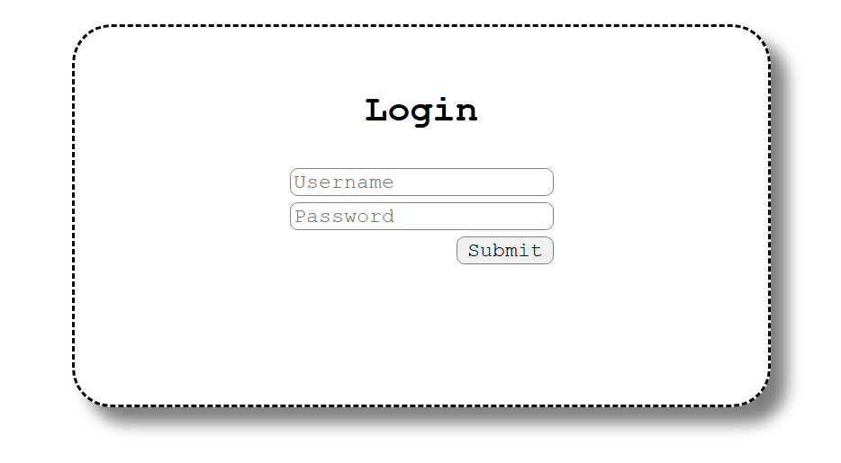

Html
<html lang="en">
<head>
<meta charset="UTF-8">
<meta name="viewport" content="width=device-width, initial-scale=1.0">
<title>Document</title>
<link rel="stylesheet" href="soal2.css" type="text/css">
</head>
<body>
<div class="container">
<div class="navbar">
<div class="icon">
<h2>Logo</h2>
</div>

<div class="menu">
<ul>
<li><a href="#">Home</a></li>
<li><a href="#">Collection</a></li>
<li><a href="#">About</a></li>
</ul>
</div>
</div>
<div class="content">
<h1>When I was<br> a kid</h1>
<p>Nona ambon pica pica.</p>
</div>
<section class="collection">
<h2>Collections</h2>
<div class="grid">
<figure class="card">
<img src="card1.jpg" alt="Product 1">
<figcaption>Product 1</figcaption>
</figure>
<figure class="card">
<img src="card2.jpg" alt="Product 2">
<figcaption>Product 2</figcaption>
</figure>
<figure class="card">
<img src="card3.jpg" alt="Product 3">
<figcaption>Product 3</figcaption>
</figure>
<figure class="card">
<img src="card1.jpg" alt="Product 4">
<figcaption>Product 4</figcaption>
</figure>
</div>
</section>
</div>
</body>
</html>

Css
* {
margin: 0;
padding: 0;
box-sizing: border-box;
font-family: 'Courier New', Courier, monospace;
}

.navbar {
width: 100%;
height: 60px;
background-color: black;
display: flex;
align-items: center;
justify-content: space-between;
padding: 0 50px;
position: fixed;
top: 0;
}

/* Logo */
.icon {
color: white;
}

/* Menu */
.menu ul {
display: flex;
}

.menu ul li {
margin-left: 40px;
}

.menu ul li a {
color: white;
transition: color 0.3s;
}

.menu ul li a:hover {
color: orange;
}

.content{
background-image: url('bg.jpg');
background-size: cover;
background-position: center;

margin-top: 80px;
padding: 40px;
text-align: left;
color: white;
justify-content: center;
display: flex;
flex-direction: column;

border-radius: 45px;
border-style: dashed;
height: 60%;
}
.collections {
margin: 40px auto 80px;
}
.grid {
display: grid;
grid-template-columns: repeat(4, 1fr);
gap: 28px;
}
.card{
display: flex;
flex-direction: column;
}
.card img {
width: 100%;
height: 160px;
object-fit: cover;
border-radius: 12px;
}
.card figcaption {
margin-top: 10px;
font-size: 20px;
text-align: center;
}
@media (max-width: 768px){
.grid{ grid-template-columns: repeat(2, 1fr); }
.navbar{ padding: 0 20px; height: 56px; }
}

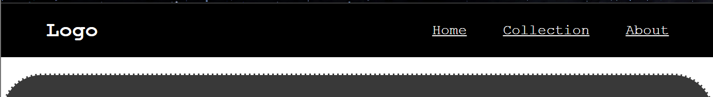
.menu ul li {
margin-left: 40px;
}
Untuk memberikan jarak antar menu
justify-content: space-between;
untuk memberikan jarak antara logo dan menu

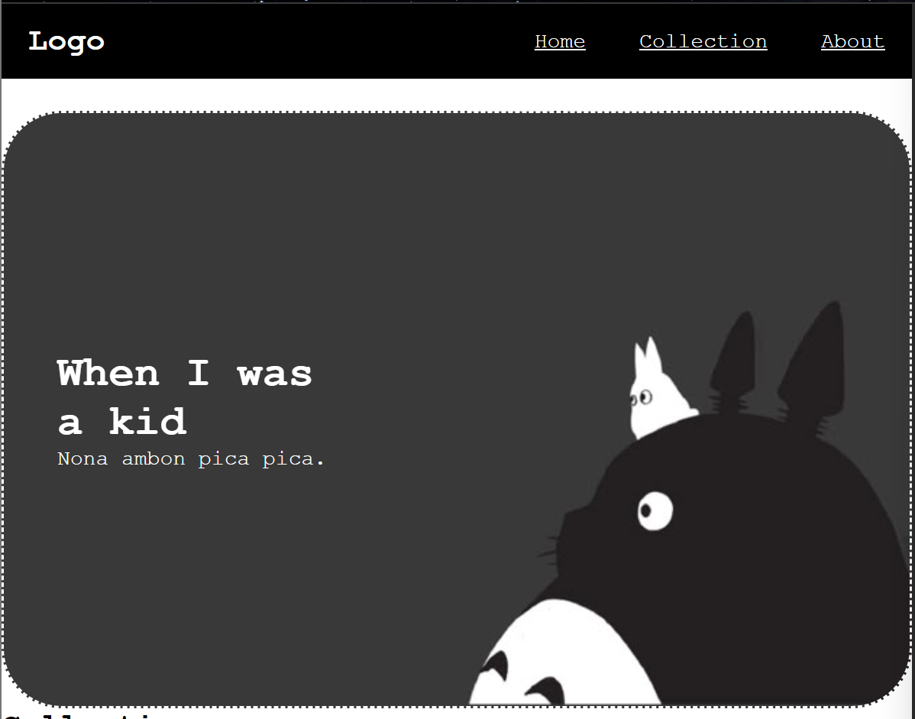
Membuat div content dengan bg image gambar yg dimau
justify-content: center;
display: flex;
flex-direction: column;
agar text ditengah

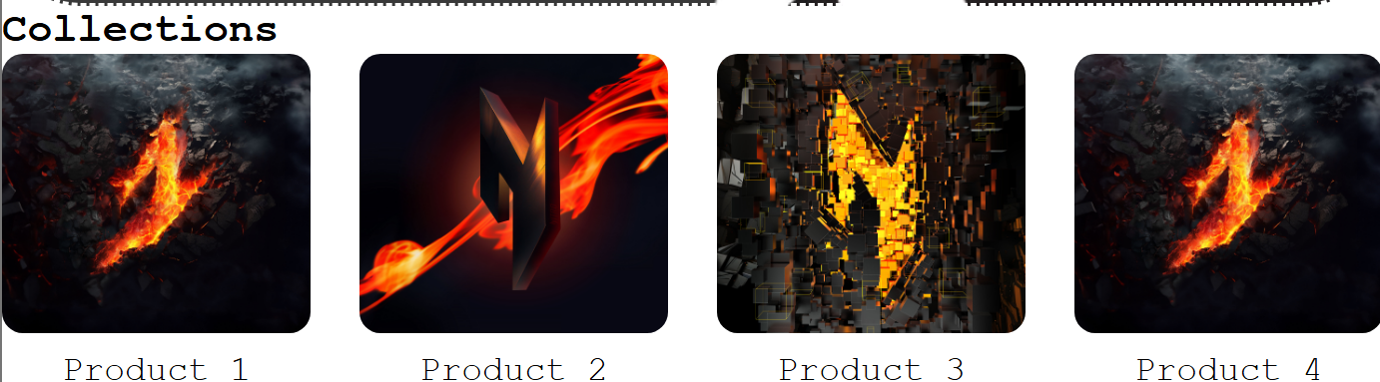
Semua figure / card memiliki class yg sama, trs hanya tinggal disamakan ukurannya

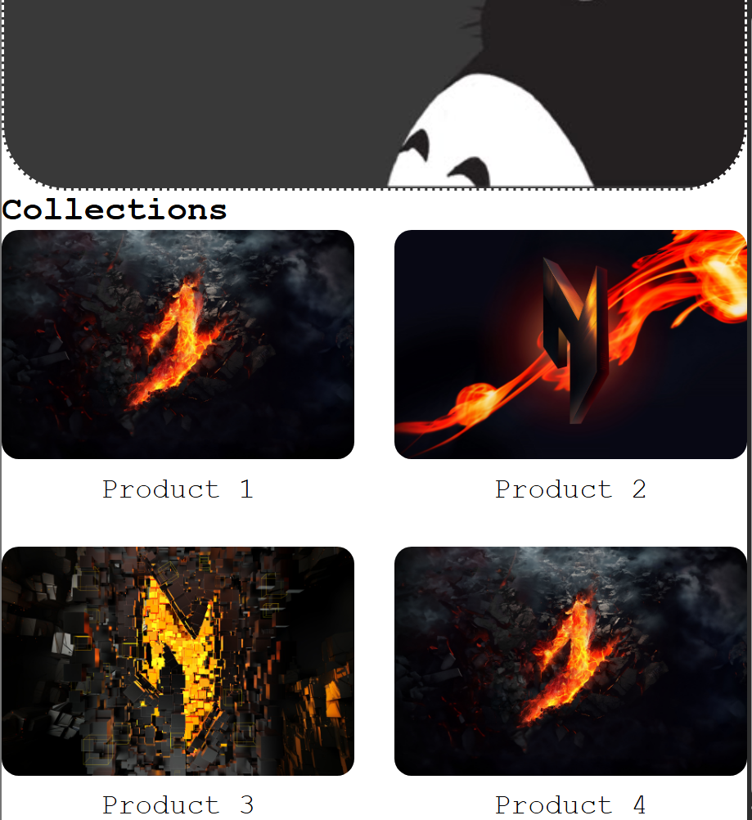
@media (max-width: 768px){
.grid{ grid-template-columns: repeat(2, 1fr); }
.navbar{ padding: 0 20px; height: 56px; }
}
Membuat kondisi seperti itu, Ketika media yg dimaksud lebih dari 764px, maka grid nya akan berubah

